SET 29: STUDENT ACADEMIC PERFORMANCE
Aim
To analyze student academic performance data using R programming by creating a stacked area chart, boxplot, and density plot, and to design an interactive scatter plot in Tableau.
Dataset
The dataset contains Student_ID, Age, Study_Hours, Attendance (%), Test_Score, and Participation_Score.
R Code – Create Dataset
student <- data.frame(
Student_ID = c("S1", "S2", "S3", "S4", "S5"),
Age = c(19, 21, 20, 22, 23),
Study_Hours = c(12, 8, 15, 10, 7),
Attendance = c(90, 70, 95, 85, 60),
Test_Score = c(85, 70, 92, 80, 65),
Participation_Score = c(8, 7, 9, 8, 6)
)
student
Question 1: Create a Stacked Area Chart for Test Score and Participation Score
R Code
library(ggplot2)
library(reshape2)

student$Student_No <- 1:nrow(student)
long <- melt(student[, c("Student_No", "Test_Score", "Participation_Score")],
id.vars = "Student_No",
variable.name = "Measure", value.name = "Score")

ggplot(long, aes(x = Student_No, y = Score, fill = Measure)) +
geom_area() +
scale_x_continuous(breaks = 1:5, labels = student$Student_ID) +
labs(
title = "Test Score and Participation Score Across Students",
x = "Student",
y = "Score"
)
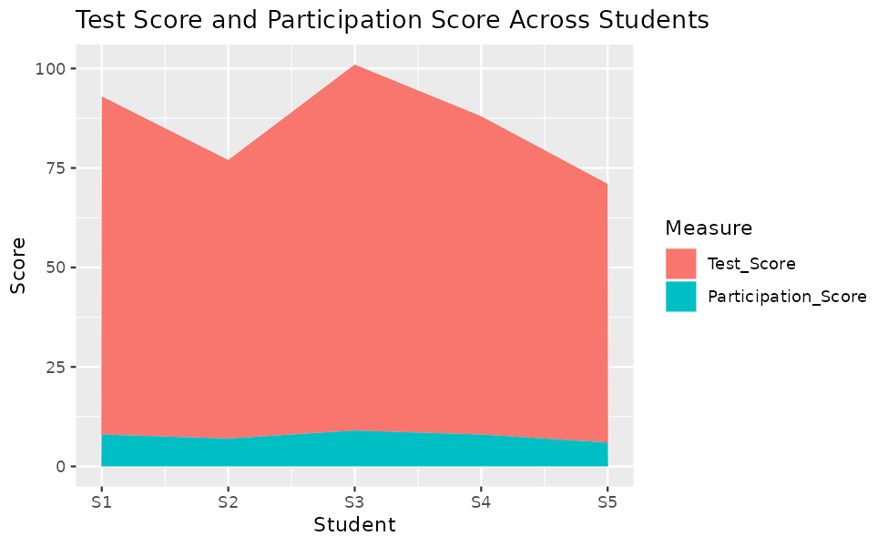
Result
The stacked area chart shows the Test_Score and Participation_Score of each student. The combined height is highest for S3 (101) and lowest for S5 (71), with S1 (93), S4 (88), and S2 (77) in between.
Both scores rise and fall together. Students with high test scores also have high participation scores, which shows that active participation is linked to better academic performance.

Question 2: Generate a Boxplot of Study Hours Grouped by Attendance Quartiles
R Code
q <- quantile(student$Attendance, probs = c(0, 0.25, 0.5, 0.75, 1))

student$Attendance_Quartile <- cut(student$Attendance, breaks = q,
include.lowest = TRUE,
labels = c("Q1", "Q2", "Q3", "Q4"))

ggplot(student, aes(x = Attendance_Quartile, y = Study_Hours,
fill = Attendance_Quartile)) +
geom_boxplot() +
labs(
title = "Study Hours by Attendance Quartile",
x = "Attendance Quartile",
y = "Study Hours",
fill = "Quartile"
)

boxplot.stats(student$Study_Hours)$out
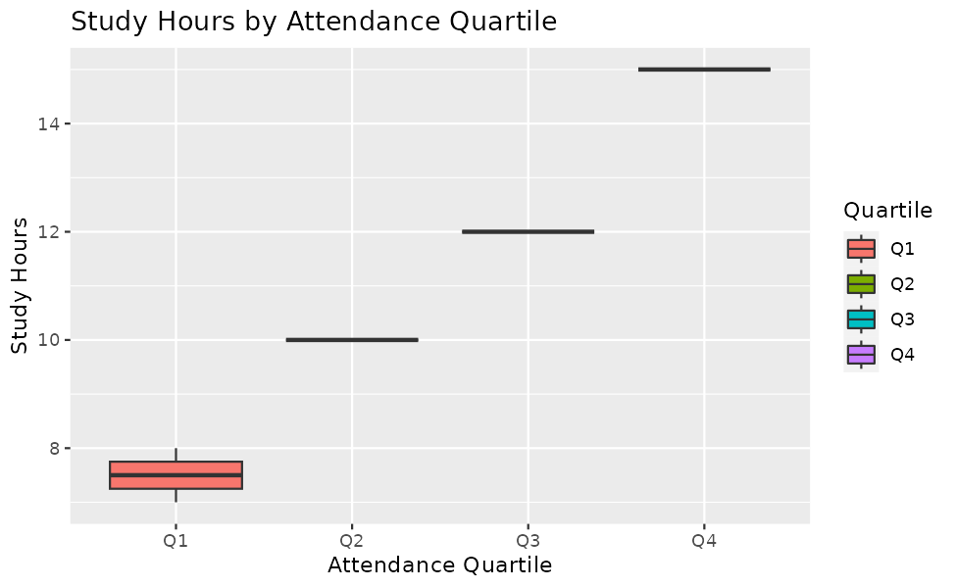
Result
The attendance quartiles are Q1 (60 to 70 %), Q2 (70 to 85 %), Q3 (85 to 90 %), and Q4 (90 to 95 %). The median study hours are 7.5 for Q1 (interquartile range 0.5, from 7.25 to 7.75), 10 for Q2, 12 for Q3, and 15 for Q4.
The median study hours increase steadily as attendance increases, which shows that students who attend more classes also study for more hours. No outliers were found in the study hours. Q2, Q3, and Q4 contain only one student each, so their boxes appear as single lines.

Question 3: Construct a Density Plot for Test Score
R Code
ggplot(student, aes(x = Test_Score)) +
geom_density(fill = "skyblue", alpha = 0.6) +
geom_rug() +
labs(
title = "Density Plot of Test Score",
x = "Test Score",
y = "Density"
)

summary(student$Test_Score)
boxplot.stats(student$Test_Score)$out
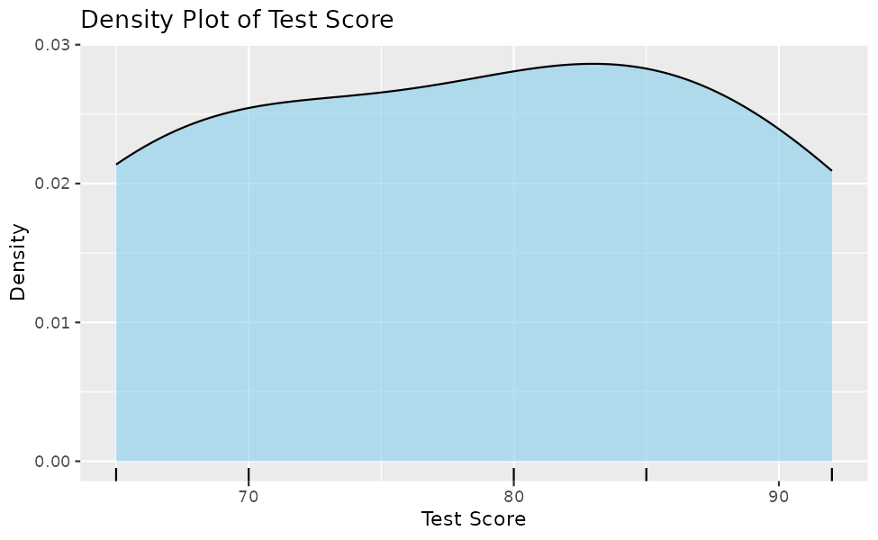
Result
The test scores range from 65 to 92, with a median of 80 and a mean of 78.4. The first quartile is 70 and the third quartile is 85. The density curve is spread across the range with no single sharp peak, and the mean being slightly lower than the median shows a slight skew towards the lower scores.
No outliers were found in the test scores, since every score lies within the range of 47.5 to 107.5 calculated using the interquartile range.

Question 4: Design an Interactive Scatter Plot in Tableau
Procedure (Tableau)
Step 1: Save the student dataset as a CSV or Excel file and connect it to Tableau.
Step 2: Drag Study_Hours to Columns and Test_Score to Rows. Disable Aggregate Measures from the Analysis menu, or drag Student_ID to Detail, so that each student appears as a point.
Step 3: Drag Participation_Score to Color and set the mark type to Circle. Drag Student_ID to Label.
Step 4: Drag Age to the Filters shelf, right-click it, select Show Filter, and choose the slider format.
Step 5: Add a trend line from the Analytics pane if required, and give the sheet a title.
(Insert the Tableau dashboard screenshot here)
Result
The interactive scatter plot shows Study_Hours on the X-axis and Test_Score on the Y-axis, coloured by Participation_Score, with a filter for Age.
Students who study more hours score higher marks, and the darker colours for high participation scores appear at the upper right of the plot. S3 (15 hours, 92 marks, participation 9) performs best, while S5 (7 hours, 65 marks, participation 6) performs lowest.

